Persistence
The persistence for the VMS system is built based on Hibernate. Hibernate enables Application to access data from any database in a platform-independent manner. There is no need for the Application to depend on the low-level JDBC details like managing connection, dealing with statements and result sets. All the necessary details for accessing a particular data source is easily configurable in Xml files.

One of the problem with using Hibernate is that the client Application that accesses the database using Hibernate Framework has to depend on the Hibernate APIs like Configuration, SessionFactory and Session. These objects will continue to get scattered across the code throughout the Application. Moreover, the Application code has to manually maintain and manage these objects. In the case of Spring, the business objects can be highly configurable with the help of IOC Container. In simple words, the state of an object can be externalized from the Application code. It means that now it is possible to use the Hibernate objects as Spring Beans and they can enjoy all the facilities that Spring provides.

The details of DAO method design, would be left to the programmer.

XML File Format Specification
This section deals with configuring the various information needed for the Spring Framework. In Spring, all the business objects are configured in Xml file as Spring Beans. These Spring Beans are maintained by the IOC which is given to the Client Application upon request. The hibernate-Spring bean mapping is defined as follows:
<beans>
<!-- Hibernate SessionFactory -->
<bean id="sessionFactory"
class="org.springframework.orm.hibernate3.annotation.AnnotationSessionFactoryBean">
<property name="dataSource" ref="dataSource" />
<property name="packagesToScan">
<list>
<value>sg.edu.nus.iss.vms.staffmgmt.dto</value>
</list>
</property>
<property name="hibernateProperties">
<props>
<prop key="hibernate.dialect">org.hibernate.dialect.MySQLDialect</prop>
<prop key="show_sql">true</prop>
</props>
</property>
</bean>

<bean id="hibernateTemplate" class="org.springframework.orm.hibernate3.HibernateTemplate">
<property name="sessionFactory" ref="sessionFactory" />
</bean>

</beans>

Since the annotations will be used instead of hibernate mapping files , the first bean defines type ' org.springframework.orm.hibernate3.annotation.AnnotationSessionFactoryBean’. AnnotationSessionFactoryBean.
The 2rd important Spring Bean is the Hibernate Template. It provides a wrapper for low-level data accessing and manipulation. Precisely, it contains methods for inserting/deleting/updating/finding data in the database. For the Hibernate Template to get configured, the only argument is the SessionFactory object as represented in the following section,

Transistion of Static Structure
The following class diagram illustrates the static structure of the design.
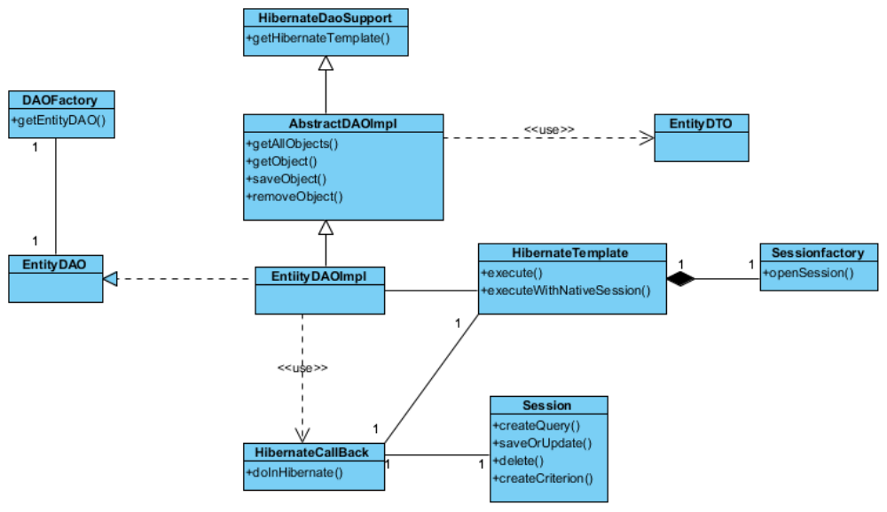

Transistion of Dynamic Interactions
The following sets of dynamic interactions are supported for each persistent entity object:
- Instantiation of a DAO
- Traversal of all the DTOs (including retrieval of the values of the attributes of the DTOs)
- Addition and Modification of a DTO
- Removal of a DTO

